Social Media Posts for Promoting Call for Abstracts

For Your 3rd Pan American Materials Congress Symposium

This document consists of two parts:
- A series of sample social media posts that you can personalize for use on your Facebook and LinkedIn accounts.
- General guidelines on using social media to promote your event, including information on how to create shortened Bitly links for ProgramMaster web addresses for concise posting, and techniques for maximizing exposure of your posting.

Part One: Sample Social Media Posts
Personalize the following announcements with your symposium name and a link to your symposium information on ProgramMaster and post to your social media sites.

- Facebook:
I’m organizing the [Your Symposium Title] for the 3rd Pan American Materials Congress. Submit your abstract by July 1, 2016. Don’t miss this opportunity to share your work and network with colleagues from across the Americas and around the world: [Add shortened Bitly link for symposium on ProgramMaster]
The Pan American Materials Congress will be co-located with the TMS 2017 Annual Meeting & Exhibition #TMS2017, held February 26–March 2, 2017 in San Diego, California.
LinkedIn:
I’m organizing the [Your Symposium Title] for the 3rd Pan American Materials Congress. Submit your abstract by July 1, 2016. Don’t miss this opportunity to share your work and network with colleagues from across the Americas and around the world: [Add shortened Bitly link for symposium on ProgramMaster]
The Pan American Materials Congress will be co-located with the TMS 2017 Annual Meeting & Exhibition, held February 26–March 2, 2017 in San Diego, California.

- Facebook:
Friends and colleagues: I’m organizing the [Your Symposium Title] symposium for the 3rd Pan American Materials Congress. Be a part of what is already coming together as an excellent program and important meeting. Submit your abstract by July 1, 2016: [Add shortened Bitly link for symposium on ProgramMaster]
The Pan American Materials Congress will be co-located with the TMS 2017 Annual Meeting & Exhibition #TMS2017, held February 26–March 2, 2017 in San Diego, California.
LinkedIn:
Friends and colleagues: I’m organizing the [Your Symposium Title] symposium for the 3rd Pan American Materials Congress. Be a part of what is already coming together as an excellent program and important meeting. Submit your abstract by July 1, 2016: [Add shortened Bitly link for symposium on ProgramMaster]
The Pan American Materials Congress will be co-located with the TMS 2017 Annual Meeting & Exhibition, held February 26–March 2, 2017 in San Diego, California.

- Facebook:
Be a part of the 3rd Pan American Materials Congress. Submit your abstract to the [Your Symposium Title] symposium I’m organizing: [Add shortened Bitly link for symposium on ProgramMaster]
The Pan American Materials Congress will be co-located with the TMS 2017 Annual Meeting & Exhibition #TMS2017, held February 26–March 2, 2017 in San Diego, California.
LinkedIn:
Be a part of the 3rd Pan American Materials Congress. Submit your abstract to the [Your Symposium Title] symposium I’m organizing: [Add shortened Bitly link for symposium on ProgramMaster]
The Pan American Materials Congress will be co-located with the TMS 2017 Annual Meeting & Exhibition, held February 26–March 2, 2017 in San Diego, California.

- Facebook:
Submit your abstract to the [Your Symposium Title] symposium that I’m organizing for the 3rd Pan American Materials Congress. Let’s make an impact on the future of the Pan American region. [Add shortened Bitly link for symposium on ProgramMaster]
The Pan American Materials Congress will be co-located with the TMS 2017 Annual Meeting & Exhibition #TMS2017, held February 26–March 2, 2017 in San Diego, California.
LinkedIn:
Submit your abstract to the [Your Symposium Title] symposium that I’m organizing for the 3rd Pan American Materials Congress. Let’s make an impact on the future of the Pan American region. [Add shortened Bitly link for symposium on ProgramMaster]
The Pan American Materials Congress will be co-located with the TMS 2017 Annual Meeting & Exhibition, held February 26–March 2, 2017 in San Diego, California

Part Two: General Instructions for Using Social Media
Facebook
For more detailed information on using Facebook, please visit Facebook’s Help Center.

What is Facebook?
Facebook is an online social networking site designed as a way to connect users and enable them to keep in touch with others via status updates. Status updates can include photos, videos, dates, locations, tags, and even feelings, (although they do not require all of that information) and appear on the news feed of anyone who is your friend on Facebook (follows you). Your Facebook friends can like or comment on your update. For more information on posting status updates, sharing photos, or sharing links, visit Facebook’s How to Post & Share page. For more information on friends or how to like an update, visit Facebook’s help section Connecting.

Tagging
Tagging is a way to link to another Facebook page, user, or place via a status update or photo that you post. Tagging enables followers of the tagged user or page to see that update. So, for example, if you tag TMS- The Minerals, Metals & Materials Society in an update, your update will appear in the news feed of TMS Facebook followers. Please tag TMS in your updates, so TMS can share on our page.
For more information on tagging and how to tag, visit Facebook’s What is tagging and how does it work? page.

Hashtags
A hashtag (the # symbol) is used to make keywords or topics in an update searchable. Hashtags are written without spaces. Clicking on a hashtag enables you to see all the updates containing that same hashtag if your account is public. As a general rule, don’t use more than two hashtags in a single posting, and, of course, only use hashtags relevant to the topic of the post. Please use #TMS2017 in your posts and updates to be a part of the TMS2017 conversation on Facebook. Learn more about using hashtags on Facebook’s help section Sharing.

LinkedIn
For more detailed information on using LinkedIn, please visit the LinkedIn Help Center.

What is LinkedIn?
LinkedIn is a business-oriented social networking service, mainly used for professional networking. You can share thoughts, links, photos, and videos through updates to your connections (like a friend on Facebook or follower on Twitter). Note that there is a limit of 600 characters on updates, and LinkedIn does not support searchable hashtags like Twitter and Facebook. For more details on sharing an update on LinkedIn, visit the LinkedIn Help Center’s entry on Sharing Ideas, Questions, Articles, and Links.

Mentions
A mention on LinkedIn is when you use an update to start a conversation with a connection or company by linking to their LinkedIn profile. Mentions are a way to get your update viewed by other connections or companies and to get them to contribute to your update. Please mention TMS in your updates (using the Group page—TMS – The Minerals, Metals & Materials Society) so TMS can interact with you on LinkedIn. For more details on how to mention a connection or company on LinkedIn, visit the LinkedIn Help Center’s entry on Mentioning People and Companies in Your Updates.

Using Bitly to Shorten Long URLs
You may have noticed that URLs for ProgramMaster are long and unwieldy, especially for posting on social media. Bitly is a free web service that automatically shortens URLs for you (to 22 characters). You do not need an account to use Bitly. Simply go to the Bitly website, and enter your long URL in the box at the top right corner of the page, then click “Shorten” button.
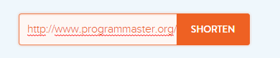
Bitly will then take you to a new page with your shortened link. From there, just click the “Copy” button and you can paste the new link on Facebook, LinkedIn, or Twitter.
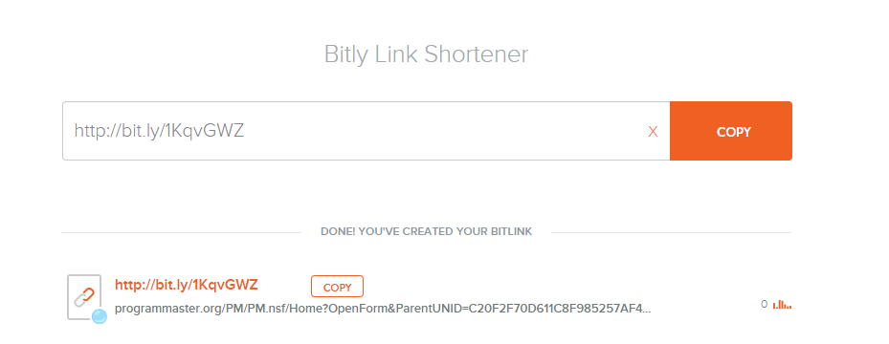
For more information on Bitly and how to use the service, visit the Bitly Support Desk for Individuals.

