THERMAL CYCLING CREEP RESISTANCE OF Ni-BASED SINGLE CRYSTAL SUPERALLOYS

Jonathan Cormier

Institut Pprime, UPR CNRS 3346, ISAE-ENSMA, 1 avenue Clément Ader, BP 40109, 86961 Futuroscope - Chasseneuil, France

Email: jonathan.cormier@ensma.fr

Keywords: Single crystal Ni-based superalloys, Thermal cycling, Creep

Ni-based single crystal superalloys are widely used in modern aeroengines and industrial gas turbines for the manufacturing of high pressure turbine blades and vanes. Their isothermal creep behavior and durability has been extensively studied in the past three decades in a wide temperature range, typically from 700°C up to ~1100°C . The main factors affecting the isothermal creep behavior and life under different applied stress and temperature conditions are well identified. Indeed, it is well known that the low temperature creep properties are highly sensitive to the γ’-size , to the specimen crystallographic orientation and to the γ’ chemical composition while very high temperature creep properties (typically above 1050°C) are mainly controlled by the remaining γ’ volume fraction and by the γ/γ’ lattice mismatch . At intermediate temperature (typically between 850°C and 1000°C for most of the commercial alloys), the creep resistance is mainly controlled by the γ’-rafting kinetics and the subsequent γ/γ’ topological inversion .

Compared to this very good knowledge of the factors affecting creep properties of Ni-based single crystal superalloys under isothermal conditions little is known about the creep properties under non-isothermal creep conditions. Having a good understanding of creep resistance under such conditions is of utmost importance for uncooled components like high pressure turbine blades of small turboshaft engines for helicopters . Indeed, the certification procedures of helicopter engines imposed by the airworthiness authorities (FAA, EASA) consist in loading histories with many thermal changes and short overheatings (up to 30 seconds) close to the γ’ solvus of the blade alloy (metal temperature as high as 20°C below the γ’ solvus) . Institut Pprime has developed a unique knowledge (for over 12 years) in performing very high temperature non isothermal creep tests, using either burner rigs (THALIE or MAATRE burners ) or creep frames with radiant furnaces. This expertise has been developed in close collaboration with SAFRAN-Turbomeca by studying the impact of a single close-γ’-solvus overheating on the high temperature creep life of MC2, CMSX-4 and MCNG alloys , by performing complex thermomechanical paths similar to engine tests and by developing microstructure sensitive constitutive equations (the Polystar model) to compute the non-isothermal creep behavior and durability of Ni-based single crystal superalloys . After recalling briefly the main results obtained from these past studies and the main factors identified as controlling the non-isothermal creep behavior (e.g. γ’ dissolution kinetics during overheating, dislocation recovery mechanisms during overheatings, etc), a special focus will be paid in this presentation to the thermal cycling creep properties. Such thermal cycling conditions are indeed representative of the most damaging steps of several engine certification tests (especially during ASMET – Accelerated Simulated Mission Endurance Test- and 150 hours tests, see blue cycles in Figure 1).

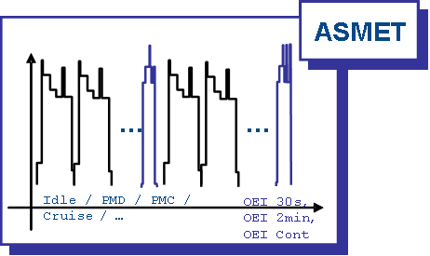

Figure 1 – Typical temperature profile during a ASMET engine test. Blue parts of the temperature history contain temperature peaks close to the γ’ solvus of the blade alloy.

In this study, the tension creep resistance under thermal cycling conditions of ten <001>-oriented Ni-based single crystal superalloys has been investigated. This database includes first generation (Mar-M200 + Hf, AM1, AM3, MC2, René N4), second generation (René N5, CMSX®-4), third generation (CMSX®-10K, CMSX®-4 Plus) and fourth generation (MCNG) alloys. The chemical compositions of these alloys are listed in Table 1. Their thermal cycling creep resistance has been investigated under an initially applied stress of 120 MPa and using a thermal cycle developed in the laboratory (15 minutes at 1050°C + 1 minute at 1105°C + 15 minutes at 1050°C + 1 minute at 1160°C/ Heating rates = 100°C/min – Cooling rates = 150°C/min) . One to five non-isothermal creep tests up to failure were performed for each alloy.

Table 1 – Chemical composition, density and γ’-solvus temperature of the alloys used for this study

Typical creep curves obtained under these conditions are shown in Figure 2. Under such conditions, it is shown that the creep resistance is mainly controlled by the very high temperature creep resistance of the alloys at 1160°C, despite temperature spikes at this temperature only last for ~ 3% of the test duration. No correlation was found with the isothermal creep resistance at the nominal temperature (i.e. at 1050°C). As an example, MC2 alloy is the most isothermal creep resistant material among the ten tested alloys at 1050°C due to its very good microstructure stability but its creep resistance is rather poor under thermal cycling conditions. Hence, as observed in Fig. 3, the number of thermal cycles up to failure is found to be closely dependent to the γ’ solvus temperature, whatever the alloy’s generation, rhenium content and creep resistance at the nominal temperature. This observation has also been confirmed by microstructural observations after failure (note that failure always occurred during a temperature dwell at 1160°C). Indeed, a higher γ’ content has been observed for alloys having a longer non-isothermal creep life. One interesting result was also observed when plotting the evolution of the time spent at 1160°C during thermal cycling creep tests normalized by the isothermal creep life at 1160°C/120 MPa plotted as a function of the isothermal creep life at 1160°C/120 MPa (Fig. 4). It is observed in this figure a steep decrease of this ratio for alloys with poor isothermal creep resistance at 1160°C and then, an almost constant ratio for alloys showing increased creep resistance at 1160°C. This results clearly indicates that for weak alloys, the non-isothermal creep resistance is mostly controlled by their intrinsic resistance at 1160°C/120 MPa while for strong alloys, the microstructure degradation (γ’ coarsening, γ’ rafting, γ/γ’ topological inversion …) which mainly takes place during nominal temperature dwells time leads to a reduce number of admissible thermal cycles. In other words, stronger alloys are more sensitive to temperature changes. This is partly due to a faster γ’ dissolution once the γ’ rafting had occurred . The detrimental effect of such microstructure degradation on the non-isothermal creep durability was also confirmed by performing a thermal degradation with or without applied stress prior to a thermal cycling creep test . After such prior microstructure degradation, the average strain rate under thermal cycling conditions was always observed to be higher than without prior microstructure degradation (i.e. with a cuboidal γ/γ’ structure).

In summary, this paper will present and analyze the mechanical behavior, the microstructure evolutions, the damage processes, the impact of a prior microstructure degradation and the reasons for the creep acceleration under very high temperature thermal cycling creep conditions. Some guidelines will finally be proposed to adjust the alloy’s chemistry to achieve a good balance between isothermal and non-isothermal creep properties for blade applications.

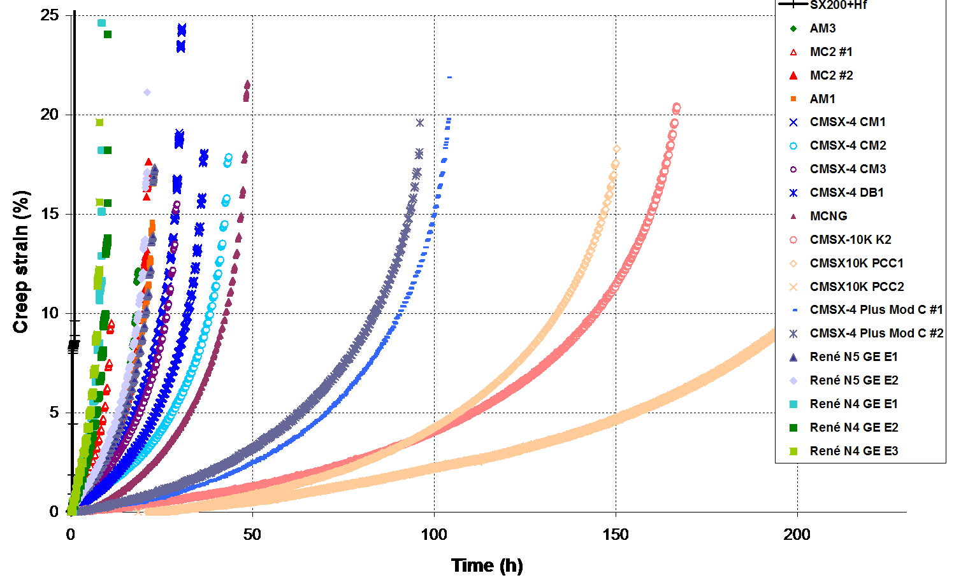
Figure 2 – Thermal cycling creep behavior of various Ni-based single crystal superalloys oriented close to a <001> crystallographic orientation. These curves have been post-processed, removing thermal strains and elastic strain variations measured during temperature changes.

Figure 3 - Creep life under very high temperature cycling conditions of various alloys as a function of the γ’ solvus temperature.

Figure 4 – Accumulated time at 1160°C during thermal cycling creep test normalized by the isothermal creep resistance at 1160°C/120 MPa plotted as a function of the isothermal creep life at 1160°C/120 MPa

Acknowledgements:

The study is a part of the long term collaboration between Institut Pprime and SAFRAN – Turbomeca on Ni-based superalloys research activities. Financial support and material supply from the company are greatly appreciated. Dr. Zéline Hervier, Dr. François Vogel, Dr. Antoine Organista (Materials Department at SAFRAN – Turbomeca) and Dr. Clara Moriconi (Mechanics of Materials Departement at SAFRAN – Turbomeca) are also greatly acknowledged for their contributions, as well as PhD and post-doc students partly involved in this study (Dr. Jean-Briac le Graverend, now at Texas A&M, Dr. Rémi Giraud, now at Erasteel, Dr. Susanne Steuer and Dipl. Eng. Lorena Mataveli Suave). Cannon-Muskegon (Dr. Ken Harris and Dr. Jacqueline Wahl) and GE Global Research (Dr. Akane Suzuki) companies are acknowledged for providing part of the material used in this study. Finally, Florence Hamon is acknowledged for her assistance in several experiments.

References

[1] R.C. Reed, The Superalloys - Fundamentals and Applications. 2006, Cambridge, UK: Cambridge University Press.
[2] P. Caron and T. Khan, Materials Science and Engineering, 1983. 61: p. 173-194.
[3] P. Caron, Y. Ohta, Y.G. Nakagawa and T. Khan in Superalloys 1988, Seven Springs, Champion, PA, USA, p. 215-224.
[4] G.L. Drew, R.C. Reed, K. Kakehi and C.M.F. Rae in Superalloys 2004, Seven Springs, Champion, PA, USA, p. 127-136.
[5] P. Caron, in Superalloys 2000. Seven Springs, Champion, PA, USA, p. 737-746.
[6] J.X. Zhang, J.C. Wang, H. Harada and Y. Koizumi, Acta Materialia, 2005. 53: p. 4623-4633.
[7] A. Epishin, T. Link, U. Bruckner and P.D. Portella, Acta Materialia, 2001. 49: p. 4017-4023.
[8] N. Matan, D.C. Cox, C.M.F. Rae and R.C. Reed, Acta Materialia, 1999. 47(7): p. 2031-2045.
[9] J. Cormier, X. Milhet, and J. Mendez, Acta Materialia, 2007. 55(18): p. 6250-6259.
[10] J. Cormier, X. Milhet, F. Vogel and J. Mendez in Superalloys 2004, Seven Springs, Champion, PA, USA, p. 941-949.
[11] J. Cormier, P. Villechaise, F. Hamon, M. Jouiad, and X. Milhet, Philosophical Magazine Letters, 90(8): p. 611-620.
[12] A. Raffaitin, D. Monceau, F. Crabos and E. Andrieu, Scripta Materiala, 2007. 56: p. 277-280.
[13] B. Viguier, F. Touratier and E. Andrieu, Philosophical Magazine, 2011. 91(35): p. 4427-4446.
[14] F. Mauget, D. Marchand, G. Benoit, M. Morisset, D. Bertheau, J. Cormier, J. Mendez, Z. Hervier, E. Ostoja-Kuczynski and C. Moriconi. in Eurosuperalloys 2014. Presqu'île de Giens, France: Matec Web of Conferences, p. 20001.
[15] J. Cormier, X. Milhet, J.-L. Champion and J. Mendez, Advanced Engineering Materials, 2008. 10(1-2): p. 56-61.
[16] R. Giraud, J. Cormier, Z. Hervier, D. Bertheau, K. Harris, J. Wahl, X. Milhet, J. Mendez and A. Organista in Superalloys 2012, Seven Springs, Champion, PA, USA, p. 265-274.
[17] J. Cormier and G. Cailletaud, Materials Science and Engineering, 2010. A527(23): p. 6300-6312.
[18] le Graverend, J.-B., J. Cormier, F. Gallerneau, P. Villechaise, S. Kruch and J. Mendez, International Journal of Plasticity, 2014. 59: p. 55-83.
[19] R. Giraud, R., Z. Hervier, J. Cormier, G. Saint-Martin, F. Hamon, X. Milhet and J. Mendez, Metallurgical and Materials Transactions A, 2013. 44A: p. 131-146.
[20] le Graverend, J.-B., J. Cormier, F. Gallerneau, S. Kruch and J. Mendez, Materials and Design, 2014. 56(April): p. 990-997.
[21] S. Steuer, Z. Hervier, S. Thabart, C. Castaing, T.M. Pollock and J. Cormier, Material Science and Engineering A, 2014. A601: p. 145-152.

